|  |  |  |  |
| --- | --- | --- | --- |
| Roll No | BACO19108 | Division | A |
| Domain Name | Data Science | | |
| Seminar Title | Neural Networks | | |
| Student Name | Ojus Jaiswal | | |
| Guide Name | Mr. Shivaji Vasekar | | |

**Abstract:**

The research on neural networks has gained significant attention in recent years due to their ability to learn complex non-linear relationships in data. Neural networks are a type of machine learning algorithm that simulate the behavior of the human brain. They have proven to be successful in various applications such as image and speech recognition, natural language processing, and fraud detection. However, they also have some limitations, including their "black box" nature, overfitting, long training times, data requirements, architecture design challenges, hyperparameter tuning, and hardware requirements. This synopsis aims to provide a comprehensive overview of neural networks, including their objective, motivation, architecture, advantages, drawbacks, applications, etc.

**Briefs about Contents**

**Objective:**

The main objective of this report is to provide an overview of Neural Networks, including their design, implementation, and applications. The report aims to identify the advantages and drawbacks of Neural Networks and how they can be used to solve real-world problems.

**Motivation:**

The motivation behind this research is to provide a comprehensive understanding of neural networks, their advantages, and limitations, as well as their applications in various fields. This report aims to assist researchers and practitioners in developing effective neural network models and optimizing their performance.

**Architectural Diagram:**

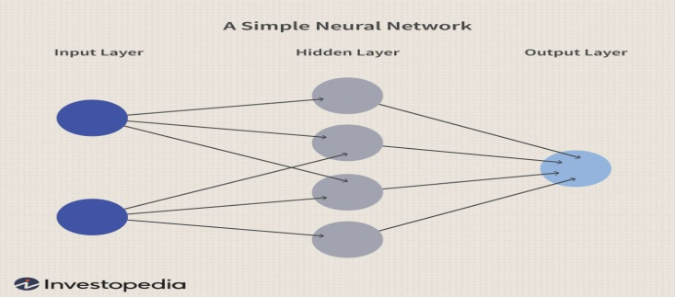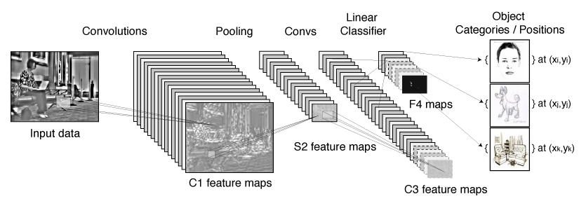

Fig. 1: Simple Neural Network Fig. 2: Convolutional Neural Network

|  |  |
| --- | --- |
| **Advantages:**   1. Non-linear modeling capability 2. High accuracy in predictions 3. Robustness to noisy data 4. Ability to learn from large datasets 5. Adaptability to changing environments | **Disadvantages:**   1. Black box nature 2. Overfitting and underfitting risks 3. Long training times 4. Hardware and software requirements |

**Applications areas**

1. Image and speech recognition: Neural networks can be used to recognize and classify images and speech with high accuracy. This technology is used in self-driving cars, face recognition, and voice assistants.
2. Natural language processing: Neural networks can be used to understand and generate human language. This technology is used in chatbots, translation software, and voice assistants.
3. Fraud detection: Neural networks can be used to detect fraudulent activities in financial transactions, credit card usage, and insurance claims.
4. Medical diagnosis: Neural networks can be used to analyze medical images and diagnose diseases such as cancer and heart disease.
5. Financial forecasting: Neural networks can be used to predict stock prices, currency exchange rates, and other financial trends.

**Conclusion:**

In conclusion, Neural Networks have become a popular and powerful tool in the field of machine learning. They offer several advantages over traditional machine learning algorithms, including the ability to learn non-linear relationships, adapt to changing inputs, and handle noisy and incomplete data. Neural Networks also offer the ability to automatically extract features from raw data, eliminating the need for manual feature engineering.

However, Neural Networks also have some drawbacks, including the "black box" nature of the models, overfitting, long training times, data requirements, architecture design challenges, hyperparameter tuning, and hardware requirements. These drawbacks highlight the need for ongoing research to address these challenges and make Neural Networks more accessible and useful for a wider range of applications.

Despite these challenges, the potential applications of Neural Networks are vast, ranging from image and speech recognition to natural language processing and fraud detection. As the field of machine learning continues to evolve, Neural Networks will likely remain a key tool for solving complex problems and making sense of large datasets. With ongoing advancements in hardware and software, the use of Neural Networks will only continue to grow in the years to come.

Signature of Student: Signature of Guide